**SR UNIVERSITY  
AI ASSITED CODING   
ASSIGNMENT – 14.5**

**NAME:** MOHAMMED MUTAKABIR HUSSAIN

**H.NO**: 2503A51L35

**BATCH**: 20

**TASK 1**

Task 1: AI-Assisted Portfolio Website  
Scenario:  
A student wants to showcase their projects, skills, and contact details in  
a portfolio website. Instead of writing all code manually, they want to  
speed up the process using GitHub Copilot.  
• Use Copilot to generate an HTML structure for a personal  
portfolio page (sections: Home, About, Projects, Contact).  
• Ask Copilot to suggest responsive CSS styling for the layout  
(e.g., grid/flexbox).  
• Customize Copilot’s suggestions to add a hover effect on project  
cards

**PROMPT:**

**CODE:**  
**OUTPUT:**

**OBSERVATION:  
ai has generated a personal portfolio page also added sections like home , About, Projects , Contact and also gave us a responsive css styling also added a hover effect on the project cards   
ai made the task simpler and easier instead of writing all code manually ai has sped up the process**

**TASK 2**  
  
**Task 2: AI-Generated Restaurant Landing Page**

**Scenario:**  
A local restaurant needs a simple landing page with a navigation bar, menu highlights, and an image gallery. The developer wants to quickly generate it using AI assistance.

* Use Copilot to create a **navigation bar with links** (Home, Menu, Gallery, Contact).
* Generate a **menu section** styled with CSS cards.
* Add a **JavaScript-based image slider** for the gallery, with Copilot suggesting the base code.

PROMPT:

CODE:  
**main page**  
**javascript**  
**Navigation bar**   
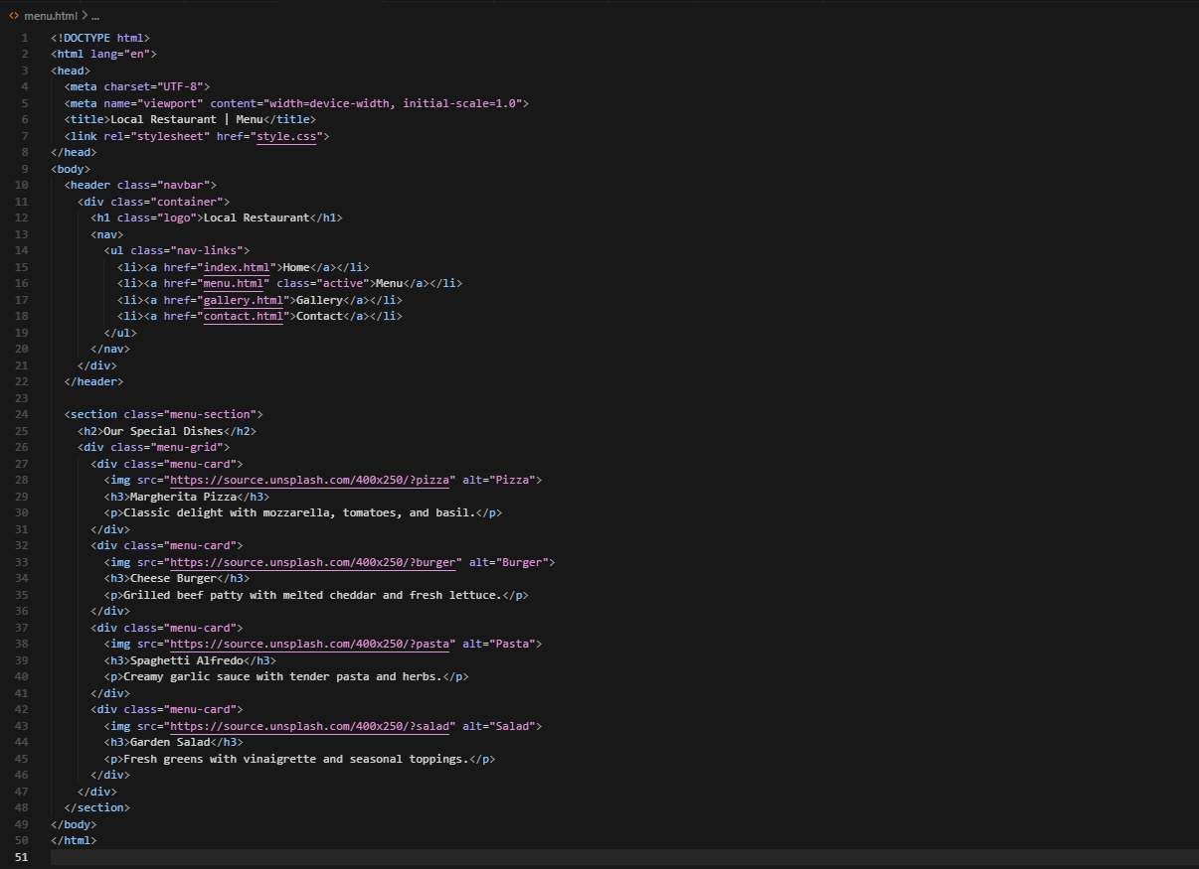  
**navigating links** 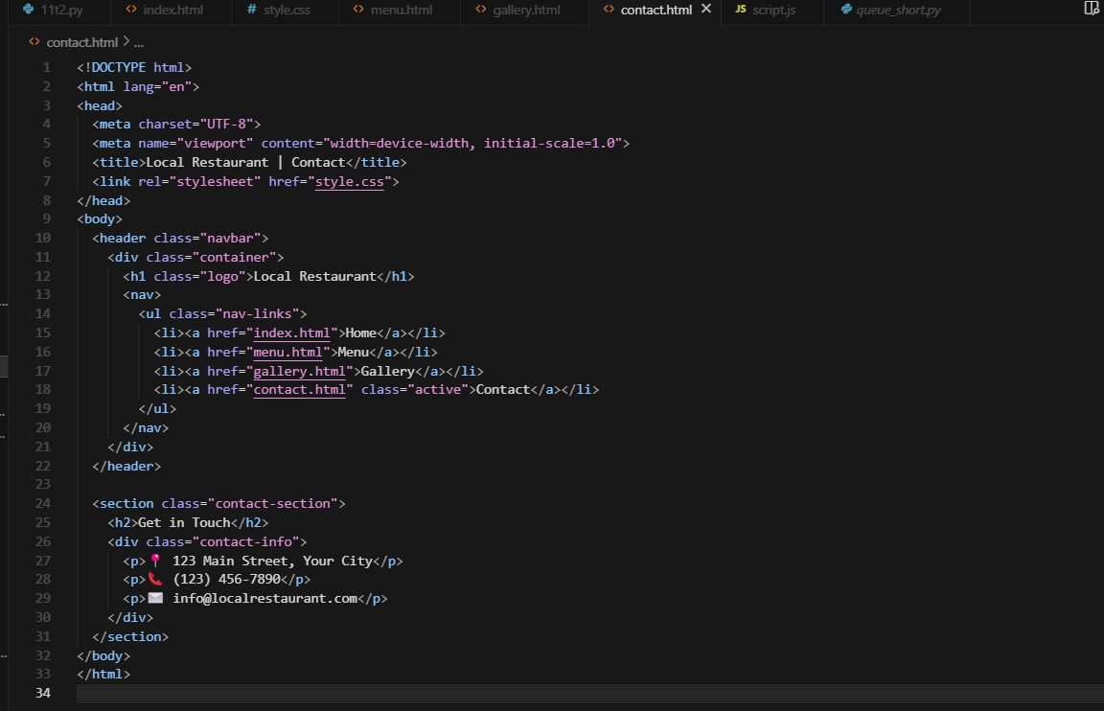  
  
**CSS**

**OUTPUT:**

**OBSERVATION:**

Ai has made the task easy and sped up the process and saved time   
It has added navigation bar and links to it to redirect to different page and also added css cards and also java based image slider for the gallery

**TASK 3**

**Task 3: AI-Powered Event Registration Form**

**Scenario:**  
SR University is hosting a tech fest. They need a web-based registration form for students. The form must validate user input in real-time.

* Ask Copilot to generate an **HTML form** (fields: Name, Email, Phone, Department, Event Selection).
* Use Copilot to assist in adding **CSS styling** for an attractive form layout.

Implement **JavaScript validation** (e.g., email format check, phone number length check) using Copilot’s suggestions  
  
**PROMPT:**

**CODE:**

**OUTPUT:**

**OBSERVATION:**  
we have generated a html form with fields like Name, Email, phone , Department , Event Selection using ai it also gave a good css styling for good layout and also javascript validation  
ai made the task more easy without manually typing the code which would take more time

**TASK 4:**

**Task 4: AI-Assisted E-Commerce Product Page**

**Scenario:**  
A startup wants a basic **e-commerce product page** to display products with prices and an “Add to Cart” button.

* Use Copilot to generate a **grid-based product catalog** in HTML/CSS.
* Implement a **JavaScript “Add to Cart” functionality** with Copilot’s guidance.
* Modify Copilot’s suggestions to include a **cart counter** at the top-right corner of the page.Top of Form

**PROMPT:**

**CODE:**  
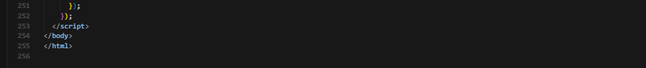

**OUTPUT:**

**OBSERVATION:**  
AI has assisted and generated a e commerce product page with a cart option and also display prices of the products and also a add to cart option   
we saved our time using ai by not manually typing in the code